https://radacad.com/dynamic-row-level-security-with-organizational-hierarchy-power-bi

<https://www.kasperonbi.com/power-bi-desktop-dynamic-security-cheat-sheet/>

[samAccountName vs userPrincipalName - MorganTechSpace](https://morgantechspace.com/2014/04/samaccountname-vs-userprincipalname.html)

[samAccountName Vs userPrincipalName (faqforge.com)](https://www.faqforge.com/windows/samaccountname-vs-userprincipalname/)

Document - RLS

Simple example

Filter - on client table

Heirachy set up

Filter based pathcontains

related to all facts as a conformed dimension otherwise will not work as expected

Assets - so can only see certain records - "filter out white noise to see usable data"

Engineers can only see certain records

Usablity rather than security

BSMCLAD2@business-stream.co.uk

MASSONDA@business-stream.co.uk -> David.Masson@business-stream.co.uk

BSONEIN1@business-stream.co.uk

BSBEITK1@business-stream.co.uk

BSBARRY1@business-stream.co.uk

BSHOODK1@business-stream.co.uk

BSARSOM1@business-stream.co.uk

https://app.powerbi.com/groups/47ecaa86-914d-4d64-a661-44f7e81d2dd3/list?ctid=18732306-2590-469d-bcc1-77318603beff

https://radacad.com/dynamic-row-level-security-with-organizational-hierarchy-power-bi

<https://www.kasperonbi.com/power-bi-desktop-dynamic-security-cheat-sheet/>

Row level security - RLS

Purpose

A report has been created which meets all the requirements of the customer. Now the customer wants to show only a certain part of the dataset to certain people. An example of this is the Sales Team manager wants to see all records for their team. When the individual members of the team log in and view the report they only see their own records.

This is the example what is going to be built is a very simple model. With two dimensions connected to single fact table.

In the screenshot below, this was the POC we created for a customer. The central fact table records when a Personal Assistant is visiting a Supported person. When a supported person logs into the Power BI service using their email address. Using RLS then only the records for the supported person will be displayed.

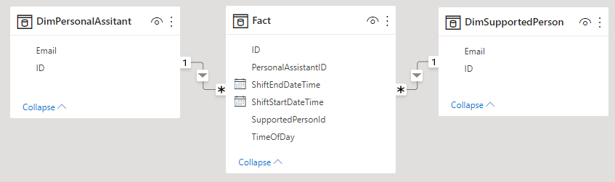Crea

**DimSupportedPerson – Table**

This has two fields

**ID** – Primary key which links to the Fact Table field PersonalAssistantID

**Email** – Text filed containing the email address of the supported person

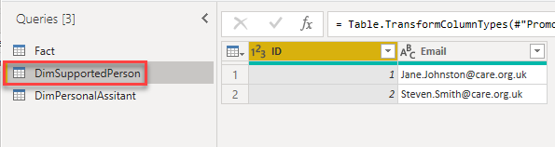

**Fact – Table**

**ID** – Primary key

**PersonalAssistantID** – this is the foreign key to DimSupportedPerson.ID This has a many to one relationship with DimSupportedPerson

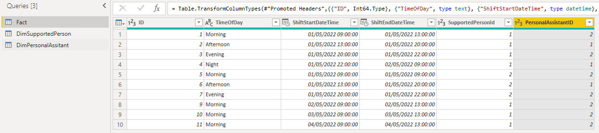

**Set up RLS in Power BI Desktop**

Create role, in Power BI desktop ensure, select ‘Home’ in the main menu, then find ‘Manage roles’.

